/*
WAP to input number and check number is Armstrong or not
153=
3 3 3
1 + 5 + 3 = 153 =1+125+27=153

8208
4 4 4 4
8 + 2 + 0 + 8 = 8208
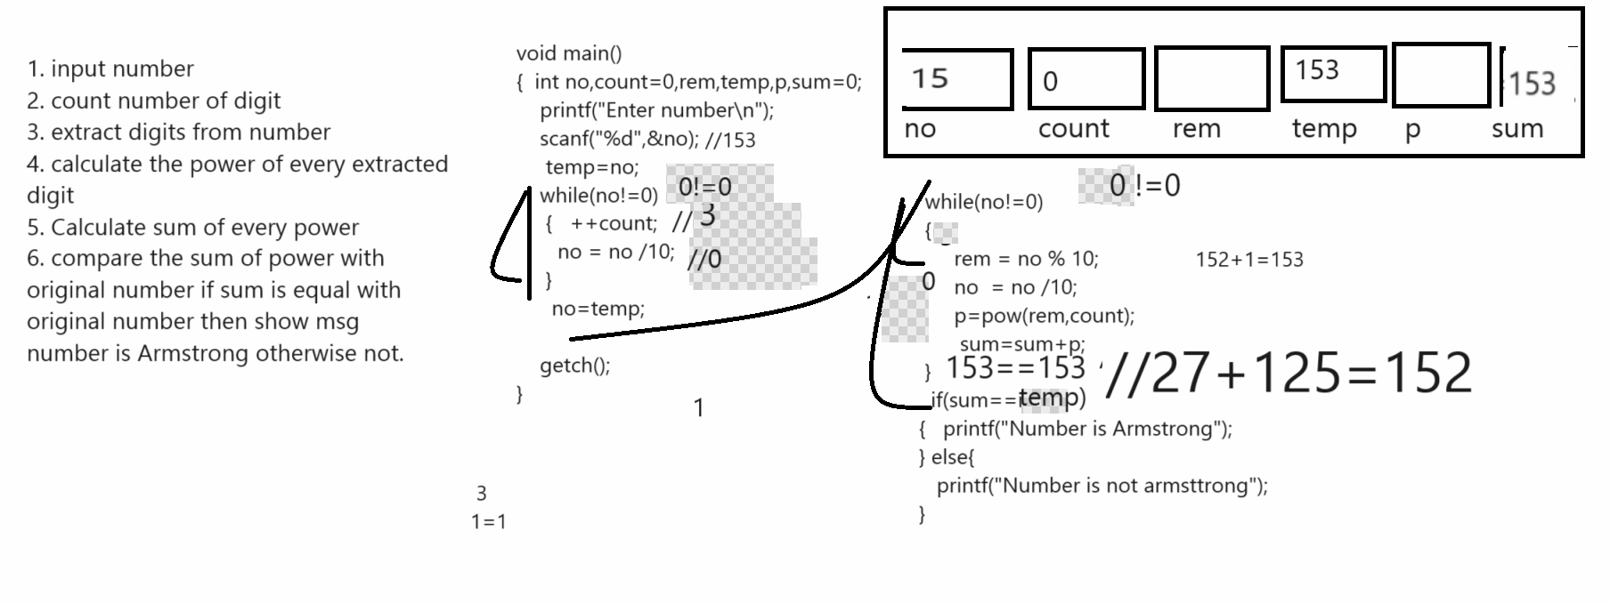

Example: WAP to input number and swap its first and last digit
123456
Output: 623451

1234
4231
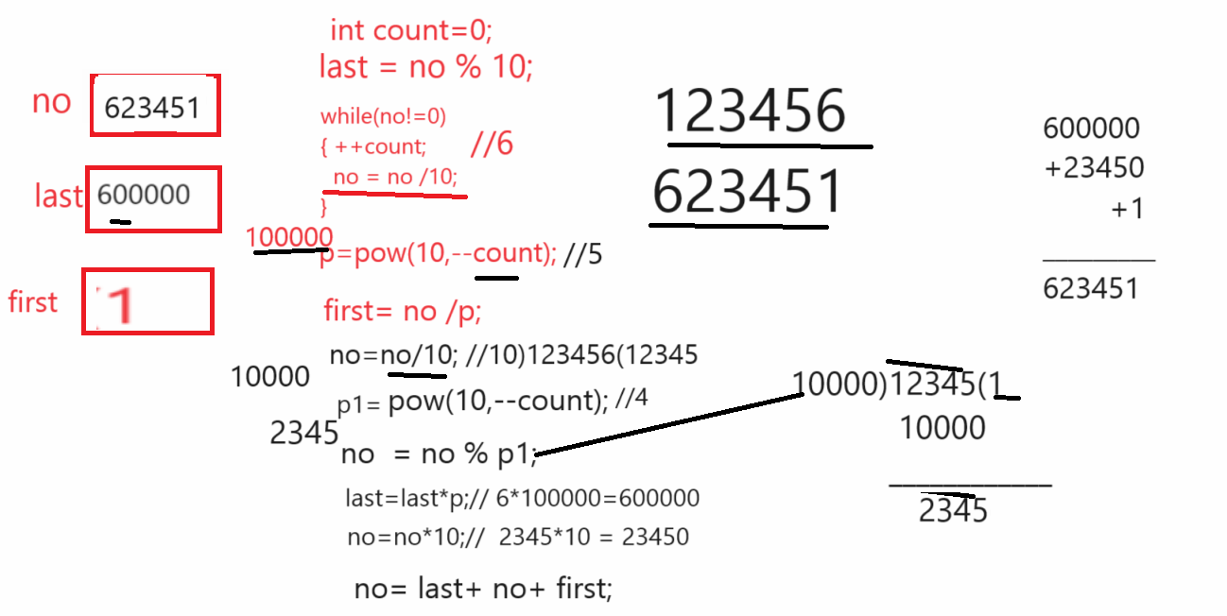

Source code Example
#include<stdio.h>
#include<conio.h>
#include<math.h>
void main(){
clrscr();
long int no,last,first,p,p1,count=0,temp;
printf("\nEnter number\n");
scanf("%ld",&no);

printf("\nBefore swapping %ld\n",no);
temp=no;
while(no!=0)
{ ++count;
no = no /10;
}
no=temp;
last=no%10;
p=pow(10,--count);
first=no/p;
no=no/10;
p1=pow(10,--count);
no=no%p1;
last=last*p;
no=no*10;
no=last+no+first;
printf("\nAfter swapping %ld\n",no);
getch();
}

